**Use case: A Patient-centric Approach to Site Selection**Homing in on sites and investigators for IgA nephropathy

In this use case, we illustrate how Citeline’s robust datasets — Sitetrove, Trialtrove, Pharmaprojects, Protocol SmartDesign, and Investigator SmartSelect — combined with real-world data, inform intelligent site and investigator selection for IgA nephropathy (IgAN) or Berger’s disease, a rare, autoimmune disease that attacks the kidneys. IgAN is the third-leading cause of chronic disease in the US.

Citeline’s patient-centric approach to site selection starts by understanding the patient journey, diving deeper into the epidemiology data, then understanding unmet medical needs, the competitive trial landscape, and strategizing site selection.

**The patient journey**

With IgAN, patients’ systems vary and may not appear for years or sometimes decades. Common signs include high blood pressure, GI problems, swelling, pink-colored urine, exhaustion, brain fog, anxiety, and depression.

**Living with IgAN: Disease Symptoms & Impact**

Sources: [Living with IgA Nephropathy](https://nephcure.org/living-with-iga-nephropathy-the-personal-stories-of-four-rare-kidney-disease-patients/), [The Voice of the Patient](https://nkf.egnyte.com/dl/aHGCS6tPNM)

Due to the lack of immediate symptoms, many patients are not diagnosed until they present with evidence of chronic kidney disease, including hematuria (blood in the urine), proteinuria (protein in the urine) and severe hypertension. Diagnosis can only be confirmed through biopsy, and 80% of patients are diagnosed between ages 16 and 35. The exact cause of IgAN is unknown, and there is no cure.

Treatment strategies aim to mitigate immune reactions, reduce IGA deposition and slow renal damage progression. The clinical course typically progresses gradually, yet between 20% to 50% of affected patients develop end-stage renal disease (ESRD) within 20 years of diagnosis. Even after receiving a transplant, 30% of patients develop an IgAN recurrence.

Source: [ISPOR—The Professional Society for Health Economics and Outcomes Research](https://www.ispor.org/docs/default-source/euro2019/igansmlisporeufinal-pdf.pdf?sfvrsn=36f58e26_0)

**Epidemiological data**

The US Food and Drug Administration (FDA) requires trial populations to be representative of real-world populations. Sponsors testing drugs in Phase III or pivotal trials must provide [diversity action plans](https://www.citeline.com/en/resources/top-10-tips-for-creating-a-diversity-action-plan). That’s where epidemiological data can help.

Let’s compare race-level epidemiological from literature to RWD. An international study reported difference by race, where patients in Asia had the highest incident rate at a whopping 4.2 per 100,000 followed by the US, where white patients of European descent had an incidence of 0.39 to 1.4 per 100,000. and Black patients are a smaller minority.

RWD corroborates that incidence varies based on race, with Asian patients being more commonly and severely affected. In the US, IgAN appears to affect white populations more than Black or Hispanic individuals disproportionately. In other US states, literature and RWD are in agreement on gender-level epidemiology. IgAN is more common in males than females, though the differences are starker in literature.

So as you select sites, you'll need to recruit more male patients among whites, up to 6 to 1; Asians, 2 to 1; and Black patients 1.6 to 1 in the US. However, you should recruit both genders equally when conducting IgAN trials in East Asia.

**Social determinants of health (SDOH)**

Using SDOH, we see the average patient lives in the suburbs, has access to public transportation, and is taking prednisone for IgAN. In fact, prescription claims are dominated by prednisone, particularly among white and Black patients, and patients receive similar prescriptions regardless of gender age or SDOH.

So which patients — and, specifically, what underserved populations— do we target? Trials need to include Asian populations. What gaps are there in treatment and how can we differentiate assets? Currently there's a gap in treatment to slow renal decline and ultimately kidney failure. This gap is already closing up; the FDA has accelerated approval for Novartis’s Fabhalta (iptacopan), the first and only drug to reduce proteinuria in IgAN patients.

Meet Tau, “patient X.”Tau, is of Asian descent, identifies as male and was diagnosed with IgAN in the past 48 hours. He is eager to sign up for a clinical trial, preferably to a study that is near his home in Irvine, CA.

**A look at the pipeline & landscape**

Source: Pharmaprojects

When we observe the drug pipeline, we see it is skewed toward early stage but has the potential for a busy late-stage pipeline in the near future. Newer modalities are being investigated, with small molecules constituting less than 50% of the pipeline. Though complement inhibition still dominates, there are a number of less-well established mechanisms.  
  
**IgAN Global Planned & Ongoing Trial Landscape**

The competitive trial landscape of planned and completed studies for all phases and is a busy one. Currently there are more than 50 drugs in the pipeline in 71 trials. Anyone planning a Phase III trial, or conducting a Phase III trial that has not met enrollment targets should look for sites now, especially with added pressure finding a diverse group of patients. There are 17 ongoing phase three studies and another 19 Phase II trials that will be competing for patients soon.

**IgAN Competitive Trial Landscape**

17 Phase III trials, mean enrollment rate is 1.31 pts/site/mo. & average accrual was 282 subjects

Source: Trialtrove

Here's a look at how the 17 Phase III trials are anticipated to progress over time. Three more trials were planned to start by the end of 2024. On average, the enrollment is 282 subjects over the span of 24 months with an enrollment rate of only 1.31 patients per site per month. Successful recruitment requires a patient-centric approach.

Source: Sitetrove

**Finding the needle in the haystack**

So how do we find IgAN patients and the most qualified and trusted investigators to ensure timely site start-up and hit our recruitment targets? We do this by starting with patients like Tau, identifying which ones match the study protocol and help us meet diversity action plans. We see almost 8,000 IgAN patients across the US. We immediately see that we need to go to sites in California. Tau is one of 1,303 patients in California diagnosed with IgAN.

We can easily break down the heat map further and look at a patient's race, gender, age group, and social determinants of health to see what states they are located in, drilling down to which county or city. We can also dive deeper than disease level in five patients, matching to protocol requirements and diversity action plans. We can view this subgroup of patients to include site, pharmacy, and the names and contact information of their primary care physician and nephrologist.

Citeline’s patient data is quite granular and comprehensive. Here we have selected patients by more than one demographic criteria, race, and education level or income level to ensure everyone has access to new therapies regardless of income level. We can also understand the total composition of patients at a site if that is of interest and view the patient's diversity details. We have done that for one IgAN site, and provided the top 10 disease areas with the highest patient volumes as well as IgAN.

**IgAN Investigator Heat Map**  
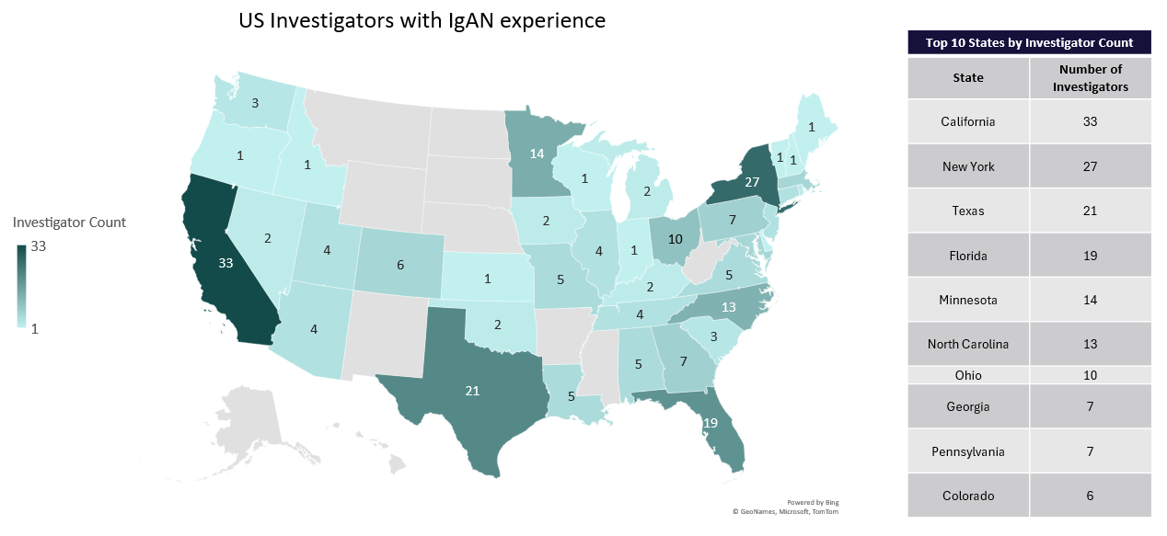 Source: Sitetrove

Once we identify the patients like Tao and their location, we can select sites based on qualified investigators who are located near the IgAN patients or have experience in decentralized clinical trials (DCTs). To help with site selection, we can rank the investigators by their IgAN trial experience, availability, patient access, and faster enrollment rate at the study level. Additionally, we can view their overall trial experience in Phase III studies, rare diseases, DCTs, real-world evidence (RWE) trials, and proteinuria trials. We can filter out anyone from trials that were terminated due to poor enrollment or have red regulatory action flags. Lastly, with RWD, we can add other variables like referral networks to get an idea of who the most trusted nephrologists are.

Connecting the dots between patients and clinical trials, we must compare the patient location with potential IgAN investigators, especially those with the desired trial experience and qualifications needed. This heat map of IgAN investigators tells us that the majority are in California, followed by New York, Texas, and Florida. Again, we can drill down investigator results to city and site level.

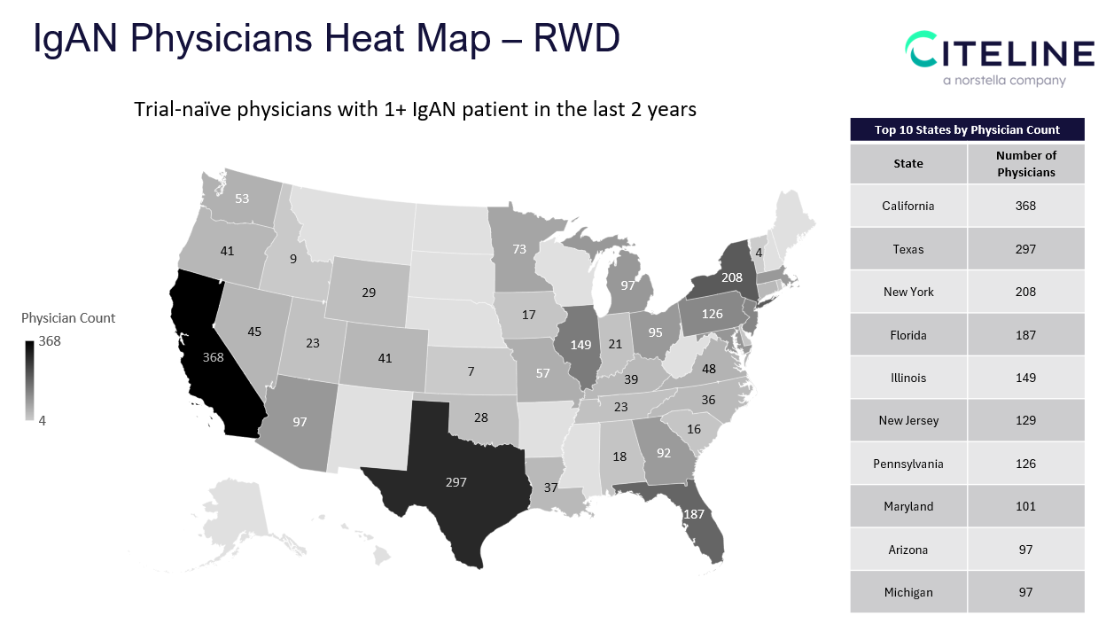  
 Source: Sitetrove

The heat map of IgAN trial-naïve shows physicians with access to IgAN patients and may be interested in being part of the referral network. California takes the lead, followed by Texas, Tennessee, Texas, New York, Florida, and Illinois.

**A closer look at trial-naïve patients**

* Total – **4,704 physicians** with IgAN patients specialize in nephrology and are not linked in Sitetrove to a IgAN trial
* 166 of these physicians are investigators in a non-IgAN study
  + **23 investigators** have access to 10+ IgAN patients
  + **15 investigators** have access to Asian patients; **7** have access to Black patients; **10** have access to Hispanic patients; **32** have access to rural patients
  + **2 investigators** are located in the states where no IgAN investigators were found (Arkansas, Mississippi)

**Referral Network**

1. **providers** have no trial experience (any indication) and have access to

* **10+ patients**
* **67 providers** have access to
* **20+ IgAN patients**

**21 providers** have access to

* **30+ IgAN patients**

We know right from the top we don't want anybody with a red flag. These are investigators who have failed an FDA inspection, are disqualified or barred from trials. We also might want to filter out anybody who has worked on trials that were terminated due to poor enrollment.

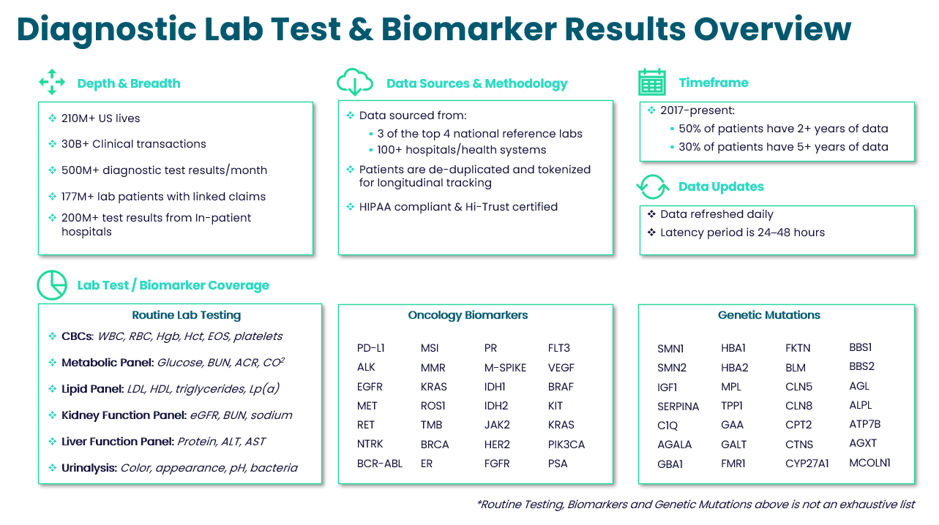

At Citeline, we pull it all together. We understand what demographics to target. After comparing EPI data to literature and RWD, we know our patients. We have their diversity data and where they are located as well as lab and procedure data to ensure they match the protocol requirements. We have a list of qualitative investigators and their proximity to IgAN patients as well as potential referral networks.

This patient-centric approach to site selection helps ensure that each patient receives the right medications at the right dose and at the right time.

**The tools behind the data**

**Trialtrove**  
Leverage data points from over 60,000 sources, curated by our expert analysts, to inform clinical trial strategy, design, and execution.  
  
**Sitetrove**  
Drill down in data from over 500,000 investigators and more than 190,000 clinical trial sites spanning 185 countries to help accelerate study cycles and mitigate risk.  
  
**Pharmaprojects**   
Track and analyze the global drug R&D landscapewith Pharmaprojects’ 90,000+ drug profiles, including 20,000 drugs in active development.  
 **Protocol SmartDesign**Streamline planning, reduce amendments, and create more predictable timelines with recommendations on primary endpoints and I/E criteria based on historical and performance data. Our robust datasets include 750k+ I/E criteria, 100k+ endpoints, 1,000+ sponsor trials, 3k+ biomarkers, plus patient segment data.

**Investigator SmartSelect**  
Generate a list of principal investigator recommendations in minutes, compared to the traditional process that can take four to six weeks. Our AI technology is backed by data curated from 550,000 investigators over 20 years: drug, patient segment, and mechanism of action. Plus investigator trial capacity, payment, epidemiology, diversity, claims, and HER data.